**Appendix 1: Assessment of Criffel Water Limited application RM16.093**

**1. Application Documents**

The applicant has provided the following documentation with the application:

* Resource Consent Application Form 1
* Resource Consent Application From 4
* Assessment of Environmental Effects by Galloway Cook Allan
* Criffel Water Limited Luggate Creek Water Volumes and Rate of Take by David Hamilton and Associates Limited
* Section 92 response
* The applicant provisionally amended their application 4th September 2019
* The applicant amended their application 19th September 2019.

**2. Description of the Site and take locations**

The applicant’s dam is located approximately 2 kilometres southeast of the intersection of Smith Road and Mount Barker Road and 6 km upstream from the State Highway 6 Road Bridge at Luggate. The dam is located on land legally described as Crown Land Block VI Tarras SD, Crown Land Block XIVI Cardrona SD, Sec 3 SO 300466. Figure 1 below shows the location of the applicant’s dam (identified by the yellow circle).

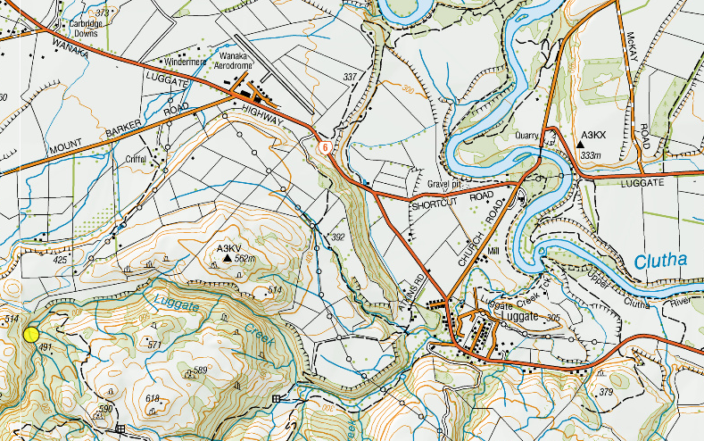

**Figure 1: Location of the applicant’s dam in relation to Luggate, Luggate Creek and the Clutha River. (Source: Otago Maps).**

The existing intake weir on Luggate Creek was constructed in 1967. When consent 2007.676 was granted for the continued use of the diversion weir used a residual flow of 50 litres per second was applied. The dam is 4.6 m high at its centre line, and has a crest length of 26 m. The maximum width of the dam at the crest is 3 m. The 680 mm diameter concrete intake pipeline is located on the true left bank of the creek, which traverses the creek gorge, until it discharges into water races further downstream. There is a steel control gate at the intake of this pipeline on the true left bank of the creek which the applicant operates to take surface water. A 900 mm steel discharge pipe which is approximately 18.3 m long runs from the upstream side of the dam and protrudes out halfway down the dam face, on the true left side of the creek (Figure 2). The rate of intake of water into the discharge pipe is also controlled by a steel control gate on a threaded riser. Access to the control gate is via a wooden walkway from the dam.

When inflows into the dam are greater than the volumes being passed by the applicant’s concrete intake and steel discharge pipe, the dam overtops. During lower flows this overtopping is concentrated towards the true right bank of the creek. Water also seeps through the base of the dam through rock crevices, which also attributes to flow beneath the applicant’s dam. These flows also provide fish passage. According to the application, water up to a depth of approximately 4.6 m is impounded upstream of the dam and covers an area of approximately 1,700 square metres (m2) during normal flow conditions. The volume of water impounded by the dam amounts to 1,500 cubic metres (m3).

**Figure 3: Photograph of applicant’s dam, and discharge pipe. (Source: Application).**

The dam is situated in the gorge of the creek, and vegetation surrounding the dam consists mainly of tussock, kanuka and manuka. Upstream of the dam, the creek flows past gravel beaches. Below the dam the bed of the creek consists mainly of rock. Figure 3 below shows the applicant’s dam, with water exiting the discharge pipe and over topping the dam. The applicant’s intake structure is located to the upper right, out of view. The location of the take point and proposed irrigation areas are generally shown on Figure 4 below.

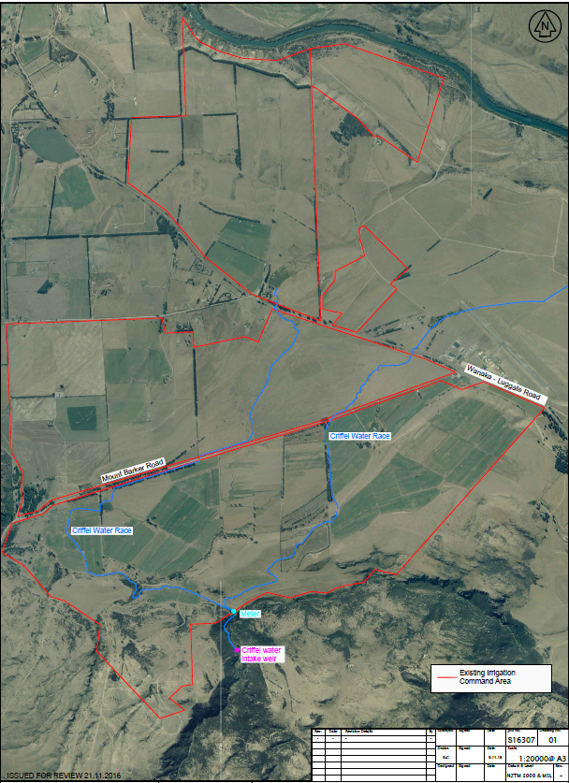

**Figure 4: Location of the point of take and irrigation areas. (Source: Application).**

The properties are located halfway between Luggate and Wanaka. The legal descriptions of the properties are attached as Appendix 4 of the application along with the relevant certificates of title. The combined properties total some 1500 hectares. The command area of the scheme is a combination of relatively flat to rolling pasture and hill country. Activities undertaken within the command area is predominately traditional pastoral farming (including some cropping), with smaller areas of horticulture and dairy support. The existing irrigation facilities better pasture growth and crop development. Currently, approximately 900 hectares is irrigated using existing irrigation measures. Future development of more efficient irrigation infrastructure will allow for a further 300 ha to be irrigated.

**3. Section 104 Evaluation**

**3.1 S104(1)(a) – Actual and potential effects on the environment of allowing the activity**

Section 104(1)(a) of the RMA requires the council to have regard to any actual and potential effects on the environment of allowing the activity. This includes both the positive and the adverse effects.

**Adverse effects**

In considering the adverse effects, the Consent Authority:

* may disregard those effects where the plan permits an activity with that effect; and
* must disregard those effects on a person who has provided written approval.

Having regard to the planning framework as set out in the body of this report, it is considered that the adverse effects of the activity on the environment that need to be assessed relate to:

* Allocation availability both primary and supplementary
* Minimum flows
* Instream values
* Downstream users and competing demand for water
* Rate, volume, timing and frequency of take of water being taken and used

**3.1.1 Primary and Supplementary Allocation**

As part of the pre-hearing process and preparing the s42A report it was recommended that the primary allocation within the catchment be reduced down to 785 L/s from 1024 L/s. This was through assessments of historic and efficient use. This caused a significant drop in potential primary allocation for both parties. The applicants working together have since been able to come to an agreement of primary allocation for the catchment with the addition of supplementary use for both takes which brings the overall primary allocation sought down to 538 L/s. This is close to the primary allocation in the Regional Plan Water that has been established for the Luggate Creek. The approach of adding supplementary takes allows the applicants to have access to water for future development whilst providing for instream values and being consistent with the NPS-FM and policies within the Regional Plan Water.

Primary allocation is defined by Policy 6.4.2of the RPW:

*“ To define the primary allocation limit for each catchment, from which surface water takes and connected groundwater takes may be granted, as the greater of:*

*(a) That specified in Schedule 2A, but where no limit is specified in Schedule 2A, 50% of the 7-day mean annual low flow; or*

1. *The sum of consented maximum instantaneous, or consented 7-day, takes of:*
2. *Surface water as at: 19 February 2005 in the Welcome Creek catchment; or 7 July 2000 in the Waianakarua catchment; or 28 February 1998 in any other catchment; and*
3. *Connected groundwater as at 10 April 2010,*

*less any quantity in a consent where:*

1. *In a catchment in Schedule 2A, the consent has a minimum flow that was set higher than that required by Schedule 2A.*
2. *All of the water taken is immediately returned to the source water body.*
3. *All of the water being taken had been delivered to the source water body for the purpose of the subsequent take.*
4. *The consent has been surrendered or has expired (except for the quantity granted to the existing consent holder in a new consent).*
5. *The consent has been cancelled (except where the quantity has been transferred to a new consent under Section 136(5).*
6. *The consent has lapsed.”*

The Schedule 2A primary allocation of the Luggate catchment set in the plan is 500 L/s. However, the existing primary allocation of the Luggate catchment (i.e. calculated in accordance with Policy 6.4.2(b)) equates to 1,024 L/s. The applicant has now reduced the primary allocation take it seeks from 601 L/s to 358 L/s and alongside that now sought from the reduced allocation of 180 L/s now sought by the Luggate Irrigation Company/Lake McKay application, the combined primary allocation that both applicants seek for the Luggate catchment is 538L/s. The applicants have come to this primary allocation for the catchment through substituting current primary allocation with supplementary allocation.

The effect of the allocation being beyond the numeric threshold means the river will sit at the minimum flow for longer, (See Appendix 3) report the minimum flow ensures the river will not fall below this number and dry out, flow variability will still be expected during rainfall events. As such the effect of the allocation limit being exceeded in this case is no more than minor.

Supplementary allocation is provided for by Policy 6.4.9 of the RPW. The policy enables access to water at moderate flows (although flows are considerably higher in over-allocated catchments), whilst maintaining the aquatic ecosystem and natural character values of affected rivers, and providing for natural flow variation:

*6.4.9 To provide for supplementary allocation for the taking of water, in blocks of allocation where that is appropriate:*

*(a) Such that up to 50% of flow at the catchment main stem, minus the assessed actual take, is available for allocation subject to a minimum flow set to ensure that no less than 50% of the natural flow remains instream; or*

*(b) On an alternative basis, provided:*

1. *The take has no measurable effect on the flow at any Schedule 2 monitoring site, or any site established in terms of Policy 6.4.4, at flows at or below any minimum flow applying to primary allocation; and*
2. *Any adverse effect on any aquatic ecosystem value or natural character of the source water body is no more than minor; and*
3. *There is no adverse effect on any lawful existing take of water.*

*(c) Supplementary allocations and associated minimum flows for some catchments are set in Schedule 2B.*

The allocation block under Policy 6.4.9(a) is calculated using Method 15.8.1A.1 of the RPW and is based on the 7-day mean annual low flow of the catchment. This method also allows for water to remain instream, to provide for aquatic ecosystems and natural character.

The allocation block under Policy 6.4.9(a) is calculated using Method 15.8.1A.1 of the RPW and is based on the 7-day mean annual low flow of the catchment. This method also allows for water to remain instream, to provide for aquatic ecosystems and natural character.

The combined primary allocation block of the Luggate catchment sought by the two applicants is538 L/s, therefore, using Method 15.8.1A.1,up to 250 L/s in the first supplementary block calculated under Policy 6.4.9 if the flow monitoring site at State Highway 6 is 788 L/s. Up to 250 L/s in the second supplementary block is available to be taken when the monitoring site State Highway 6 is flowing at 1038 L/s. Figure 5 below shows the available supplementary blocks for the Luggate Catchment with the primary allocation as sought at 538 L/s and the coupled with the 180 L/s minimum flow.

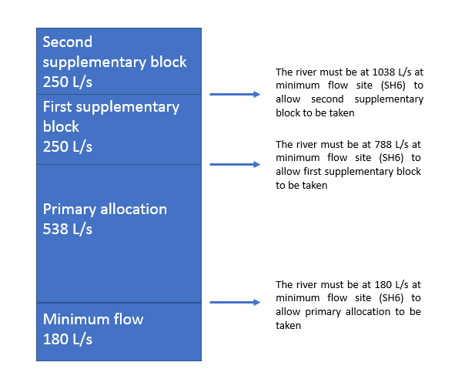

**Figure 5: Supplementary and primary allocation blocks within the Luggate Catchment.**

The applicant has applied for 170 L/s in the first supplementary block and 80 L/s in the second supplementary block shown in Table 1 below. The proposed use of the supplementary blocks will have a no more than minor effect on the catchment. As discussed in the Science assessment in Appendix 3, the proposal is not expected to result in prolonged periods of flat-lining, with flow variability largely mimicking that expected in the absence of abstraction, albeit with a lower baseflow than the natural flow regime. The main effect of the proposal is to reduce the amount of water taken at low flows (thereby resulting in higher flows than currently observed) but increasing the amount of water that is taken as flows recede from high flows. This represents an improvement in in-stream habitat availability and will significantly reduce the length of time that the river is held at low flows compared with the existing abstraction regime. The minimum flow (180 l/s) will be the primary determinant of habitat availability in Luggate Creek for juvenile trout. Therefore, taking water as supplementary allocation is expected to have a no more than minor effect.

**Table 1: Luggate Catchment allocation blocks**

|  |  |  |  |  |
| --- | --- | --- | --- | --- |
| **Allocation Block** | **Current Allocation from Flow Blocks** | **Water Take applied for by Applicants** | **Minimum Flow Restriction**  **Level** | **Remaining Allocation** |
| **Criffel Primary** | 601.8 l/s | 358 l/s | 180 l/s | Fully Allocated |
| **LIC/LM Primary** | 423 l/s | 180 l/s | 180 L/S | Fully Allocated |
| **Primary Total** | 538 l/s | 538 l/s | 180 l/s | Fully Allocated |
| **1st Supplementary** | Nil | 250 l/s | 788 l/s | Fully Allocated |
| **2nd Supplementary** | Nil | 166 l/s | 1038 l/s | 84 l/s |
| **Total Takes** |  | **954 l/s** |  |  |

**3.1.2 Minimum Flow**

Minimum flows may be set for a river or catchment for the purpose of restricting when primary allocation takes of water may not be exercised. A minimum flow provides for the maintenance of aquatic ecosystem and natural character values of water bodies, while providing for the sustainable taking of water for use. Once set in Schedule 2A of the RPW, they are imposed on all relevant consents in that catchment. When a minimum flow is breached, all consents to take water as primary allocation (with some exceptions), must cease.

As this take is primary allocation from the Luggate catchment,any consent granted will be subject to the minimum flow set in Schedule 2A of the RPW of 180 L/s (1 November to 30 April) and 500 L/s (1 May to 20 October) at the State Highway 6 monitoring site.

**3.1.3 Effects on Fish and Instream Values**

With regard to the effects on the instream values of a surface water body, the following can be considered under the restricted discretionary considerations listed by *Rule(s) 12.1.4.8*:

* the need for a residual flow at the point of take;
* the rate, volume, timing and frequency of water to be taken and used;
* the proposed methods of take;
* the need to prevent fish entering the intake and to locate new points of take to avoid adverse effects on fish spawning sites; and
* any effect on any Regionally Significant Wetland or on any regionally significant wetland value.

In addition to a minimum flow, a residual flow may be set at the point of take, for the purpose of providing for instream values of the source water body. As discussed in Appendix 3 Dean Olsen from Ryder Environmental Limited has assessed that Luggate Creek and the Alice Burn have instream values. The Ryder Environment Limited report concludes that a residual flow of 90 l/s is appropriate and will protect instream values, especially given that greater flows are in fact likely to be necessary here at times in order to maintain the minimum flow for the catchment downstream.

During surveys undertaken on the Luggate Creek rainbow trout were observed upstream of the Criffel intake. Therefore, Mr Olsen has recommended fish screening is required at the take. The applicant has proposed fish screening therefore the effect on fish values will be no more than minor. Comments on fish screening are in Appendix 3 and are covered in the proposed conditions set out in Appendix 6.

There are no Regionally Significant Wetlands or any known regionally significant wetland values that will be affected by the proposed water take. Therefore, there are no effects on Regionally Significant Wetlands.

**3.1.4 Effects on Other Water Users**

There is one downstream user, Luggate Irrigation Company. The applicant has proposed a 90 L/s residual flow and there is a minimum flow on the Luggate Catchment. The applicant has entered into a low flow agreement with Luggate Irrigation Company to ensure the catchment will adhere to the minimum flow and both parties can cut back when necessary. Due to the proposed residual flow, minimum flow and rationing regime effects on the downstream user are no more than minor.

In this context, neither the Criffel application nor the Luggate Irrigation application currently form part of the existing environment. Both applications are only at the application stage and therefore any adverse effects on the other consent holder must be assessed with reference only to the effect of the proposed activities on the exercise on the existing deemed permits held by the parties (and only up until the expiry of the consents).

**3.1.5 Rate, volume, timing and frequency of water being taken and used**

The means and timing of the take, and the rate at which water is proposed to be taken, described in Section 2 of this report, are not anticipated to have any adverse effects on instream values. The lower primary allocation instantaneous rate will ensure the applicant has to efficiently irrigate the land. Therefore, effects of the proposed rate of take are considered to be no more than minor.

The addition of supplementary allocation enables the future development of the land. The applicant has proposed the supplementary allocation be able to be taken year-round to ensure the water can be utilised for storage. As the supplementary take will ensure that values within the streams are protected the effect of the year round taking is assessed as no more than minor.

**3.1.6 Positive Effects**

The proposal will have the following positive effects:

* Reduction in consented rates of takes from what has been previously authorised, with overall positive effects on flows and instream values, compared with the current situation;
* Economic well-being of the farming operation and flow-on effects from this on the local economy and community;
* Social benefits by supporting the families and workers who directly rely on the farm
* Provides greater certainty for the farming production than is possible with dryland faming
* Maintenance of pasture quality over a critical dry period/crops are not affected by moisture stress at critical growing times
* Conversion to more efficient application methods proposed, which will minimise losses of water

**3.2 S104(1)(ab)**

We are not aware of any specific offset or compensation proposal provided by the applicant, at this stage.