RM22.434.01 – Land use consent to disturb the bed of the Clutha River / Mata-Au associated with suction dredging
Draft conditions,
Conditions:
Specific
- The use of the bed of the Clutha River / Mata-u for suction dredge mining activities must be carried out in accordance with the plans and all information submitted with the application, detailed below, and all referenced by the Consent Authority as consent number RM22.434.
  - Application form, and assessment of environmental effects dated 14 May 2021 (lodged with Otago Regional Council on 19 September 2022), including:
    - Freshwater Assessment prepared by E3 Scientific, dated July 2022; and
    - Cold Gold Clutha Limited Maritime Transport Operator Plan (version 7), dated June 2021 (or an updated approved version of this plan); and
    - Noise testing (between Ettrick and Millers Flat), un-named expert, testing dated October 2013; and
    - Hydraulic and flow assessment of Rongahere Road slipway, Flood Sense Limited, site visit dated January 2021.
  - Further information response dated 19 April 2023, including:
    - Ecology memo titled ‘Response to Cultural Impact Assessment – Suction dredge gold mining in the Clutha River’, E3 Scientific, dated 19 April 2023
  - Further information response dated 18 July 2023, including:
    - Letter titled ‘RE: Cold Gold Consent Conditions’ including proposed conditions as Appendix 1, E3 Scientific, dated 19 July 2023.
If there are any inconsistencies between the above information and the conditions of this consent, the conditions of this consent will prevail.
- This consent must only be exercised in conjunction with Water Permit RM22.434.02 and Discharge Permit RM22.434.03.
- Prior to the exercise of this permit the consent holder must surrender RM20.087.01-.03
- Prior to the exercise of this permit the Consent Holder shall provide evidence to the Council demonstrating that it holds Public Liability Insurance of no less than $5 Million Dollars. The consent holder must maintain this level of insurance at all times while exercising this consent and the associated permits RM22.434.02-04. Evidence of the insurance being held shall be provided to the Council on request.
- Following the commencement of dredging pursuant to this consent the consent holder may not operate any dredge vessel within the application area other than CGC1.
Exclusion areas and times
- This consent authorises the use of the bed of the Clutha River / Mata-Au for suction dredge mining, between the downstream of the Luggate Bridge (NZTM 2000: E1305697 N5040203) and the confluence with Lake Dunstan (NZTM 2000: E1307834 N5018386), with the following exclusion areas where suction dredge mining is prohibited:
  - From 100 m upstream of the confluence of Luggate Creek with the Clutha River / Mata-Au (NZTM 2000: E1305436 N5038955) and for a distance of 350 m downstream, terminating at the downstream extent of the island within Devils Nook (NZTM 2000: E1305651 N5039249); and
  - The delta portion of the Clutha River / Mata-Au from the confluence with Lake Dunstan (NZTM 2000: E1307834 N5018386) to the confluence with the Lindis River (NZTM 2000: E1310744 N5024139); and
  - Within 50 metres upstream or downstream of the confluence of the Clutha River / Mata-Au with the following tributaries:
    - Schoolhouse Creek – NZTM 2000: E1311169 N5025645;
    - Albert Burn – NZTM 2000: E1310796 N5027432;
    - Un-named watercourse 2,800 metres downstream of Poison Creek – NZTM 2000: E1311002 N5031354;
    - Poison Burn – NZTM 2000: E1310645 N5032755;
    - Un-named watercourse 2,360 upstream of Poison Creek - NZTM 2000: E1310619 N5034837;
    - Sheepskin Creek – NZTM 2000: E1306683 N5038687; and
    - Trig Burn – NZTM 2000: E1309559 N5038286; and
  - Within 50 metres of the confluence of the Clutha River / Mata-Au with any tributary of a width greater than 1 metre, measured 1 metre beyond the confluence with the Clutha River / Mata-Au.
  - Within 20 metres of any lawful surface water take.
The exclusion areas where suction dredge mining is prohibited under condition 3(a), 3(b) and 3(c) are identified in the attached Appendix 1.
- During sports fish spawning season (1 April to 31 October), the Consent Holder must not undertake suction dredging activities in water less than 1 m deep.
- The Consent Holder must ensure that no beaches that are part of the dry bed when the flow in the Clutha River / Mata-Au is 400 cubic metres per second or less are disturbed.
- The suction dredging activity including start-up and shut-down must be carried out for no more than 12 hours each day between the hours of 8:00 am and 8:00 pm, Monday to Sunday. No works are to occur on public holidays and between 24 December and 03 January or Easter, Waitangi and Labour Day Weekends.
- If relocating the suction dredge, the Consent Holder must not commence suction dredging activities within 150 metres of an angler that is actively fishing.
- To manage risks relating to working around overhead power lines, the Consent Holder must ensure that:
  - The total height of the dredge, including any antenna or other fixtures that can articulate and extend vertically above the craft, must be no more than 7.5 metres vertically above the water line;
  - No structure associated with the suction dredging activity comes within 15 metres of any high voltage line;
  - Any work under other electricity lines must maintain a 4 metres minimum approach distance from the conductors as per the New Zealand Electrical Code of Practice for Electrical Safe Distances 34: 2001; and
  - Any work within 4 metres of electricity lines, the Consent Holder and/or their contractors are to hold at all times, an active and approved Aurora Energy Limited overhead close approach permit.

Dredge management
- The Consent Holder must take all measures to ensure the dredge and any associated equipment is secured in high flows and flooding events, to prevent it from becoming an obstruction or blockage in the river channel and damaging any bridges, dams or other structures.
- The Consent Holder must ensure that a GPS device is on the dredge to continuously record the location of the dredge, in relation to areas of operation authorised by this consent. This information must be made available publicly on a website and provided to the Consent Authority upon request.
- Prior to commencing operation of the dredge the Consent Holder shall provide to the Council the website address where the dredge location will be available.
- Prior to the exercise of this consent, the Consent Holder must ensure that:
  - An industry standard hose and filler nozzle with automatic cut-off is fitted for refuelling equipment;
  - An additional shutoff valve is fitted to the handle and a remote stop push button and cable accessible at the filler nozzle location to stop the pump at the bulk tank;
  - The bulk onshore fuel tank is double skinned or bunded and is located in an area that is above 1 in 50 year flood levels, in a safely accessible location;
  - Spill kits are located at the bulk tank and onboard the dredge; and
  - All staff receive training in the location and use of spill kits.
- Except as provided for by Discharge Permit RM22.434.03, the Consent Holder must ensure that no contaminants, including fuel or oil, enter the Clutha River / Mata-Au. In the event of any discharge of contaminants to the Clutha River / Mata-Au (other than water containing sediment in accordance with RM22.434.03), the Consent Holder must undertake immediate remedial action and must notify the Consent Authority within 24 hours of the discharge.
- The consent holder shall establish and maintain a portaloo for use by staff at the same location as the fuel storage tank.
Performance Monitoring
- The Consent Holder must submit an Annual Work Programme for the period 1 April to 31 March to the Consent Authority by 28 February each year, or as required throughout the year if updates to the Annual Work Programme are required.
- The Annual Work Programme must at minimum include (but not be limited to):
  - Maps and GPS co-ordinates in NZTM 2000 identifying the upper and lower extent of each 1,500 metre section the Consent Holder would like to operate in during the period 1 April to 31 March of the upcoming year.
  - Bird nesting exclusion areas as identified in table 1;
  - Monitoring requirements and procedures for refuelling;
  - Contingency plans in the event of system malfunctions or breakdowns;
  - The means of receiving and dealing with complaints; and
  - Emergency contact phone numbers, including the ORC Pollution Hotline (0800 800 033).
- A record of activity undertaken in accordance with this consent must be submitted to the Consent Authority by 31 May annually, for the previous 1 April to 31 March period, and made available for inspection at other times upon request. The report must at a minimum include (but not be limited to):
  - Records showing the location of dredging activity complied with the Annual Work Programme, including the provision of GPS co-ordinates in NZTM 2000.
  - Records of any malfunctions and breakdowns in the refuelling system and any remedial action undertaken;
  - Records relating to the emptying of the Cassette toilet and waste oil containers including, date and location of disposal.
  - A record of any complaints received, including:
    - The date, time, location and nature of the complaint;
    - The name, phone number and address of the complainant (unless the complainant elects not to supply this information);
    - Action taken by the Consent Holder to remedy the situation and any policies or methods put in place to avoid the issue occurring again and/or mitigate the effects of the issue;
  - Records of any fish entrainment as required by condition 17; and
  - Evidence of avoidance of the bird nesting exclusion areas as identified in conditions 18 and 19
  - Record of any breaches (including date and time) of the turbidity standards in RM22.434.03 and the steps taken to adjust the dredging activity to achieve compliance again.
- The Consent Holder must maintain a record of any fish observed to be entrained by the suction dredge, including:
  - Species (if identifiable);
  - Time and date;
  - GPS co-ordinates in NZTM 2000;

- If suction dredging is planned to occur within 100m of the sites identified in table 1 below between 1 July and 31 March each year the Consent Holder must have a suitably qualified and experienced ecologist conduct a survey within10 working days prior to commencing work to determine whether any of the following species are utilising the area for nesting
  - a. Black-billed gulls
    - b. black fronted terns
    - d. South Island Pied Oystercatcher
    - e. Pied Stilt
    - f. Banded Dotterel
    - g. Southern Black-backed Gull
    - h. Caspian Tern
    - Little pied Shag
    - Black Shag

  - If any of the above species are found to be utilising the areas for breeding no suction dredging activity may commence within 100m of the area and the consent holder must establish at least 6 pest traps around the breeding area in locations specified by the ecologist. Following placement, the traps must be checked at least weekly and reset if necessary. Placement of the pest traps is subject to consent being given by the landowner of the site where the breeding birds are located. If landowner consent is not given, the consent holder is not required to place traps.

Table 1: Table of beaches where endemic riverine bird surveys should occur prior to suction dredging within 100m during the breeding season. A map is included as Appendix 1.
Beach number | NZTM Easting | NZTM Northing
Beach 1 | 1306798.3 | 5038683.2
Beach 2 | 1310279.3 | 5037263.1
Beach 3 | 1310103.1 | 5037036.9
Beach 4 | 1309772.0 | 5036786.2
Beach 5 | 1309910.6 | 5036378.4
Beach 6 | 1310693.3 | 5034601.4
Beach 7 | 1310427.2 | 5033923.9
Beach 8 | 1310767.2 | 5032784.1
Beach 9 | 1311308.2 | 5033102.5
Beach 10 | 1311406.9 | 5026128.5
Beach 11 | 1311141.5 | 5025218.5

- The Consent Holder must notify the Otago Regional Council Harbour Master of the location of any land-based fuel tank associated with the suction dredging activity at least 10 working days prior to the installation of any fuel tank.

- Prior to commencing suction dredging activity in any location the consent holder must:
  - Conduct a visual inspection of the area to be dredged to determine whether the area contains any Lagarosiphon major. Where the water is too deep to see the river bottom the consent holder must utilise the camera located on the end of the suction dredge nozzle.
  - If Lagarosiphon Major is identified in the area, no suction dredging activity may be undertaken.

General
- The Consent Holder must ensure that all persons operating the dredge have read and are familiar with the conditions of these consents. A copy of the consent documents must be kept on the dredge at all times.
- The Consent Holder must ensure that any bed disturbance is limited to the extent necessary to carry out the works.
- On completion of each mining area, the Consent Holder must ensure that all plant, equipment, signage, debris, rubbish and any other material brought onto the site is removed from the site.
- The Consent Holder must not excavate or disturb any riverbanks of the Clutha River / Mata-Au, or disturb any vegetated areas adjoining the Clutha River / Mata-Au, except for providing access to the riverbed as authorised under RM22.434.04.
- The Consent Holder must ensure that any suction dredging activities authorised by this consent do not result in any flooding, erosion, scour, land instability or property damage.
- The consent holder must take all reasonable precautions to minimise the spread of pest plants and aquatic weeds. In particular, the consent holder must:
  - Waterblast all machinery to remove any visible dirt and/or vegetation prior to being brought on-site to reduce the potential for pest species being introduced to the bed of the watercourse. Machinery and equipment that has worked in watercourses must, prior to entering the site, also be cleaned with suitable chemicals or agents to kill didymo;
  - and
  - To avoid the spread of the Didymosphenia geminata or any other pest plant, not use machinery in the berm or bed of the river that has been used in any area where the pest plants are known to be present in the previous 20 working days, unless the machinery has been thoroughly cleansed with a decontamination solution (for information on decontamination contact the Consent Authority’s Biosecurity Team);
  - Remove any vegetation caught on the machinery at the completion of works;
  - Prior to leaving the site, water blast all machinery following the completion of works to reduce the potential for pest species being spread from the bed of the watercourse.
- In the event that an unidentified archaeological site is located during the suction dredging activity, the following will apply:
  - Works must cease immediately at that place and within 20 metres around the site.
  - All machinery must be shut down, the area must be secured, and Heritage New Zealand Pouhere Taonga Regional Archaeologist and the Consent Authority must be notified.
  - If the site is of Māori origin, the Consent Holder must also notify the appropriate iwi groups or kaitiaki representative (Aukaha and Te Ao Marama Incorporated) of the discovery and ensure that access to enable appropriate cultural procedures and tikanga to be undertaken, as long as all statutory requirements under legislation are met (Heritage New Zealand Pouhere Taonga Act 2014, Protected Objectives Act 1975).
  - If human remains (kōiwi tangata) are uncovered the Consent Holder must advise the Heritage New Zealand Pouhere Taonga Regional Archaeologist, NZ Police, the Consent Authority and the appropriate iwi groups or kaitiaki representative and the above process under (c) will apply. Remains are not to be disturbed or moved until such time as iwi and Heritage New Zealand Pouhere Taonga have responded.
  - Works affecting the archaeological site and any human remains (kōiwi tangata) must not resume until Heritage New Zealand Pouhere Taonga gives written approval for work to continue. Further assessment by an archaeologist may be required.
  - Where iwi so request, any information recorded as the result of the find such as a description of location and content, must be provided for their records.
- Under section 125 of the Resource Management Act 1991, this consent lapses two years after the date of commencement of the consent unless:
  - The consent is given effect to; or
  - The Consent Authority extends the period after which the consent lapses.
Review
- The Consent Authority may, in accordance with Sections 128 and 129 of the Resource Management Act 1991, serve notice on the consent holder of its intention to review the conditions of this consent within 3 months of each anniversary of the commencement of this consent for the purpose of:
  - Determining whether the conditions of this consent are adequate to deal with any adverse effect on the environment which may arise from the exercise of the consent and which it is appropriate to deal with at a later stage; or
  - Ensuring the conditions of this consent are consistent with any National Environmental Standards or National Planning Standards; or
  - Reviewing the frequency of monitoring or reporting required under this consent.
Notes to Consent Holder
- Where information is required to be provided to the Consent Authority this is provided in writing to compliance@orc.govt.nz, and the email heading is to reference RM22.434 and the condition/s the information relates to.
- Section 126 of the Resource Management Act 1991 provides that the Consent Authority may cancel this consent by written notice served on the Consent Holder if the consent has been exercised in the past but has not been exercised during the preceding five years.
- If you require a replacement consent upon the expiry date of this consent, any new application should be lodged at least 6 months prior to the expiry date of this consent. Applying at least 6 months before the expiry date may enable you to continue to exercise this consent under section 124 of the Resource Management Act 1991 until a decision is made on the replacement application (and any appeals are determined).
- The Consent Holder is responsible for obtaining all other necessary consents, permits, and licences, including those under the Building Act 2004, the Biosecurity Act 1993, the Conservation Act 1987, and the Heritage New Zealand Pouhere Taonga Act 2014. This consent does not remove the need to comply with all other applicable Acts (including the Property Law Act 2007 and the Health and Safety at Work Act 2015), regulations, relevant Bylaws, and rules of law. This consent does not constitute building consent approval. Please check whether a building consent is required under the Building Act 2004.
- Under the Heritage New Zealand Pouhere Taonga Act 2014 an archaeological site is defined as any place in New Zealand that was associated with human activity that occurred before 1900 and provides or may provide, through investigation by archaeological methods, evidence relating to the history of New Zealand (see Section 6). For pre-contact Māori sites this evidence may be in the form of Taonga (artefacts) such as toki (adzes) or flake tools as well as bones, shells, charcoal, stones etc. In later sites of European/Chinese origin, artefacts such as bottle glass, crockery etc. may be found, or evidence of old foundations, wells, drains or similar structures. Pre-1900 buildings are also considered archaeological sites. Burials/kōiwi tangata may be found from any historic period. Archaeological sites are legally protected under Sections 42(1) & (2) of the Heritage New Zealand Pouhere Taonga Act 2014. It is an offence under Section 87 of the Heritage New Zealand Pouhere Taonga Act 2014 to modify or destroy an archaeological site without an Authority from Heritage New Zealand Pouhere Taonga irrespective of whether the works are permitted, or a consent has been issued under the Resource Management Act 1993 or Building Act 1991.
- The Consent Holder will be required to pay the Consent Authority an administration and monitoring charge to recover the actual and reasonable costs incurred to ensure ongoing compliance with the conditions attached to this consent, collected in accordance with Section 36 of the Resource Management Act 1991.

Appendix 1: Location of the exclusion areas where suction dredge mining is prohibited under RM22.434.
Condition 3(a) - Exclusion area at ‘Devils Nook’: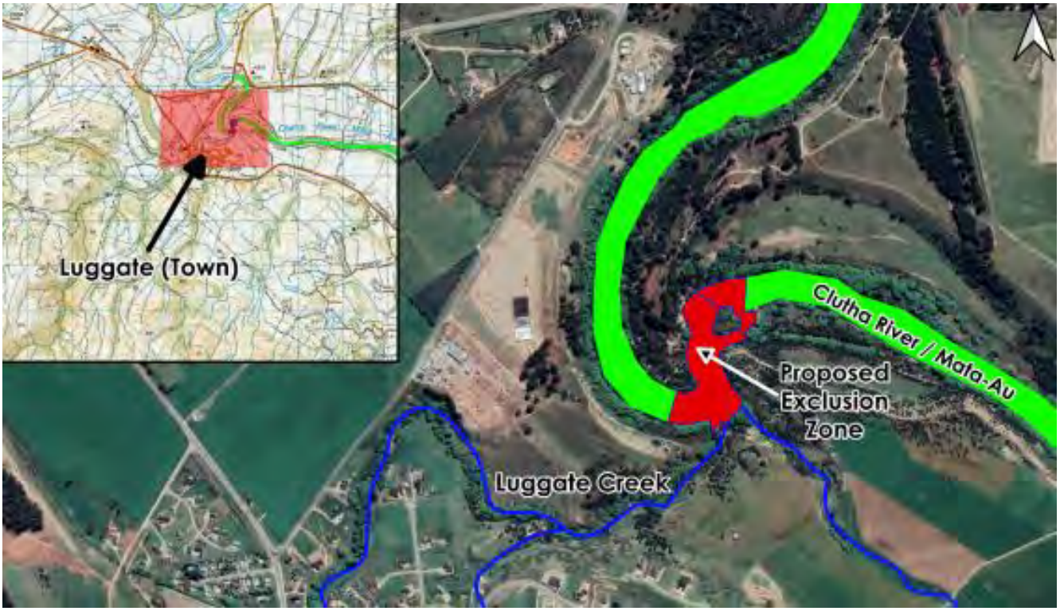
Condition 3(b) - Exclusion area between the confluence with the Lindis River and Lake Dunstan: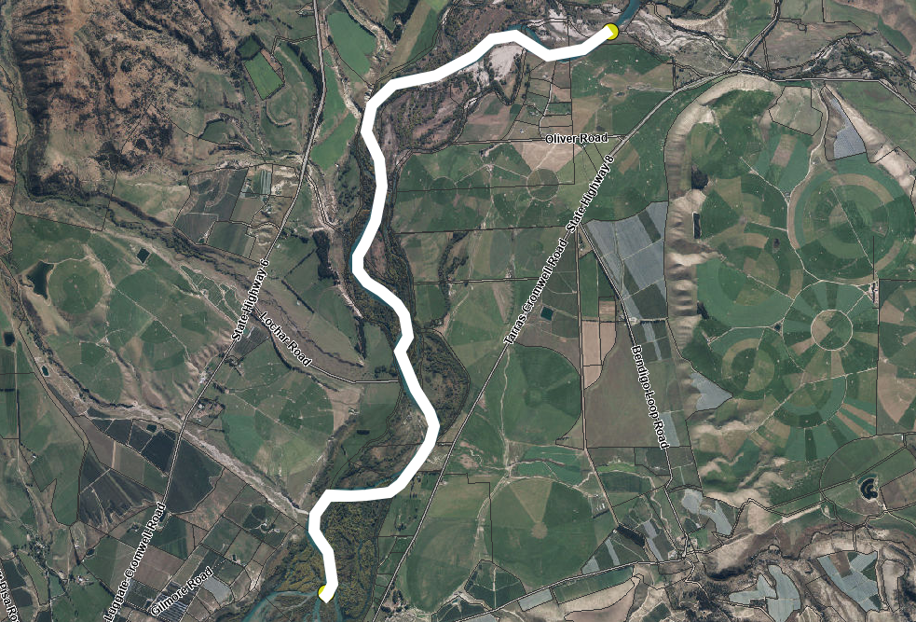
Condition 3(c) – Exclusion areas around specifically identified tributaries of the Clutha River / Mata-Au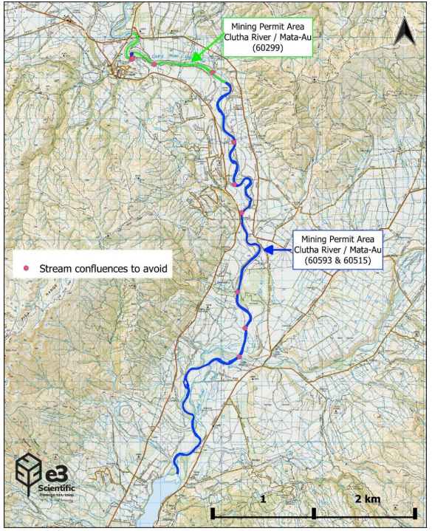

RM22.434.02 - Water permit to take and use surface water from the Clutha River / Mata-Au (non-consumptive) associated with suction dredging
Draft conditions,
Conditions:
Specific
- The take of water from the Clutha River / Mata-Au for suction dredge mining activities must be carried out in accordance with the plans and all information submitted with the application, detailed below, and all referenced by the Consent Authority as consent number RM22.434.
  - Application form, and assessment of environmental effects dated 14 May 2021 (lodged with Otago Regional Council on 19 September 2022), including:
    - Freshwater Assessment prepared by E3 Scientific, dated July 2022; and
    - Cold Gold Clutha Limited Maritime Transport Operator Plan (version 7), dated June 2021 (or an updated approved version of this plan); and
    - Noise testing (between Ettrick and Millers Flat), un-named expert, testing dated October 2013; and
    - Hydraulic and flow assessment of Rongahere Road slipway, Flood Sense Limited, site visit dated January 2021.
  - Further information response dated 19 April 2023, including:
    - Ecology memo titled ‘Response to Cultural Impact Assessment – Suction dredge gold mining in the Clutha River’, E3 Scientific, dated 19 April 2023
  - Further information response dated 18 July 2023, including:
    - Letter titled ‘RE: Cold Gold Consent Conditions’ including proposed conditions as Appendix 1, E3 Scientific, dated 19 July 2023.
If there are any inconsistencies between the above information and the conditions of this consent, the conditions of this consent will prevail.
- This consent must only be exercised in conjunction with Land Use Consent RM22.434.01 and Discharge Permit RM22.434.03.
- The rate and quantity of abstraction from the Clutha River / Mata-Au must not exceed:
  - 400 litres per second; and
  - 18,720 cubic metres per day.
- All water taken while exercising this consent must immediately be returned directly to the Clutha River / Mata-Au.
General
- Under section 125 of the Resource Management Act 1991, this consent lapses two years after the date of commencement of the consent unless:
  - The consent is given effect to; or
  - The Consent Authority extends the period after which the consent lapses.
Review
- The Consent Authority may, in accordance with Sections 128 and 129 of the Resource Management Act 1991, serve notice on the consent holder of its intention to review the conditions of this consent within 3 months of each anniversary of the commencement of this consent for the purpose of:
  - Adjusting the consented rate or volume of water under condition 3, should future changes in water use indicate that the consented rate or volume is not able to be fully utilised; or
  - Determining whether the conditions of this consent are adequate to deal with any adverse effect on the environment which may arise from the exercise of the consent and which it is appropriate to deal with at a later stage; or
  - Ensuring the conditions of this consent are consistent with any National Environmental Standards or National Planning Standards.
Notes to Consent Holder
- Section 126 of the Resource Management Act 1991 provides that the Consent Authority may cancel this consent by written notice served on the Consent Holder if the consent has been exercised in the past but has not been exercised during the preceding five years.
- If you require a replacement consent upon the expiry date of this consent, any new application should be lodged at least 6 months prior to the expiry date of this consent. Applying at least 6 months before the expiry date may enable you to continue to exercise this consent under section 124 of the Resource Management Act 1991 until a decision is made on the replacement application (and any appeals are determined).
- The Consent Holder is responsible for obtaining all other necessary consents, permits, and licences, including those under the Building Act 2004, the Biosecurity Act 1993, the Conservation Act 1987, and the Heritage New Zealand Pouhere Taonga Act 2014. This consent does not remove the need to comply with all other applicable Acts (including the Property Law Act 2007 and the Health and Safety at Work Act 2015), regulations, relevant Bylaws, and rules of law. This consent does not constitute building consent approval. Please check whether a building consent is required under the Building Act 2004.
- The Consent Holder will be required to pay the Consent Authority an administration and monitoring charge to recover the actual and reasonable costs incurred to ensure ongoing compliance with the conditions attached to this consent, collected in accordance with Section 36 of the Resource Management Act 1991.

RM22.434.03 – Discharge permit to discharge contaminants (sediment) to surface water of the Clutha River / Mata-Au associated with suction dredging
Draft conditions
Specific
- The discharge of water containing sediment from suction dredge mining activities to the Clutha River / Mata-Au must be carried out in accordance with the plans and all information submitted with the application, detailed below, and all referenced by the Consent Authority as consent number RM22.434.
  - Application form, and assessment of environmental effects dated 14 May 2021 (lodged with Otago Regional Council on 19 September 2022), including:
    - Freshwater Assessment prepared by E3 Scientific, dated July 2022; and
    - Cold Gold Clutha Limited Maritime Transport Operator Plan (version 7), dated June 2021 (or an updated approved version of this plan); and
    - Noise testing (between Ettrick and Millers Flat), un-named expert, testing dated October 2013; and
    - Hydraulic and flow assessment of Rongahere Road slipway, Flood Sense Limited, site visit dated January 2021.
  - Further information response dated 19 April 2023, including:
    - Ecology memo titled ‘Response to Cultural Impact Assessment – Suction dredge gold mining in the Clutha River’, E3 Scientific, dated 19 April 2023
  - Further information response dated 18 July 2023, including:
    - Letter titled ‘RE: Cold Gold Consent Conditions’ including proposed conditions as Appendix 1, E3 Scientific, dated 19 July 2023.
If there are any inconsistencies between the above information and the conditions of this consent, the conditions of this consent will prevail.
- If there are any inconsistencies between the above information and the conditions of this consent, the conditions of this consent will prevail.
- This consent must only be exercised in conjunction with Land Use Consent RM22.434.01 and Water Permit RM22.434.02.
- The discharge of water containing sediment must not exceed 400 litres per second and 18,720 cubic metres per day.
- Prior to the commencement of dredging activities in accordance with this consent the consent holder must remove the HDPE liner from the dredge pipe and replace it with a steel alternative.
Performance Monitoring
- The consent holder must carry out dredging operations to ensure:
  - There is no conspicuous change in colour or visual clarity of the Clutha River / Mata-Au beyond a distance of 200 metres downstream of the point of discharge at any time, subject to compliance with conditions 7 and 8.
  - If there is a conspicuous change in colour or visual clarity of the Clutha River / Mata-Au beyond a distance of 100 metres downstream of the point of discharge, the consent holder must reduce the level of discharge activity or cease the discharge until there is no conspicuous change in colour or visual clarity beyond 100 metres downstream of the point of discharge.
  - If there is a conspicuous change in colour or visual clarity of the Clutha River / Mata-Au beyond a distance of 200 metres downstream of the point of discharge, the discharge activity must cease and the Consent Holder must immediately notify the Consent Authority.
  - The consent holder must always undertake the dredging activity in a way that minimises the extent of the sediment plume, through visual observations of the plume and active management of the rate/speed of dredge.
- To assess compliance with the condition above the consent holder must:
  - Establish a camera on the stern of the dredge that records the water behind the dredge while the dredge is operating. The footage from this camera shall be retained for at least 12 months and made available to the Council on request.
  - Undertake turbidity monitoring at least twice a day (once in the morning, and once in the afternoon) as follows:
    - Take a sample immediately upstream of the dredge.
    - Take a sample at 100m behind the dredge.
    - Take a sample at 200m behind the dredge.
  - The samples taken must meet the following criteria:
    - Samples taken at 100m must achieve no more than 2NTU change if the upstream sample is less than 8NTU. Where the upstream sample is greater than 8NTU the downstream sample must not be more than 5NTU higher. If the standards are not met the dredge operator must immediately slow down or stop dredging and carry out a repeat sample within 10minutes to confirm compliance has been achieved. These standards must be met at least 80% of the time (assessed each month).
    - Samples taken at 200m must not exceed the upstream sample (excluding the sampling error of the turbidity monitor). If the 200m sample does exceed the baseline sample dredging must stop immediately and another sample taken within 10minutes to confirm compliance has been achieved. The consent holder must also notify the Council of any breach at 200m.
  - All sample data shall be recorded including the date and time and provided to the Council on request.
  - After the dredge has been operating for 2 months the consent holder shall commission a suitably qualified independent expert to review the video footage and sampling data taken in accordance with this condition and provide advice or confirmation regarding:
    - The turbidity sampling methodology and criteria are achieving compliance with condition 5;
    - Any changes that need to be made to the sampling methodology or criteria to improve compliance with condition 5.
  - The report shall be submitted to the Council within 3 months of dredging commencing operation pursuant to this consent.
  - The consent holder must adopt and operate in accordance with all the recommendations made in the report.
General
- Under section 125 of the Resource Management Act 1991, this consent lapses two years after the date of commencement of the consent unless:
  - The consent is given effect to; or
  - The Consent Authority extends the period after which the consent lapses.
Review
- The Consent Authority may, in accordance with Sections 128 and 129 of the Resource Management Act 1991, serve notice on the consent holder of its intention to review the conditions of this consent within 3 months of each anniversary of the commencement of this consent for the purpose of:
  - Adjusting the consented rate or volume of discharge under condition 4, should future changes in water use indicate that the consented rate or volume is not able to be fully utilised; or
  - Determining whether the conditions of this consent are adequate to deal with any adverse effect on the environment which may arise from the exercise of the consent and which it is appropriate to deal with at a later stage; or
  - Ensuring the conditions of this consent are consistent with any National Environmental Standards or National Planning Standards.
- The Consent Authority may, in accordance with Sections 128 and 129 of the Resource Management Act 1991, serve notice on the consent holder of its intention to review condition 6 of this consent within 3 months of the consent holder submitting the report required by condition 6(f) for the purpose of:
  - making any amendments to the method or criteria for monitoring turbidity to improve compliance with condition 5.
Notes to Consent Holder
- Where information is required to be provided to the Consent Authority this is provided in writing to compliance@orc.govt.nz, and the email heading is to reference RM22.434 and the condition/s the information relates to.
- Section 126 of the Resource Management Act 1991 provides that the Consent Authority may cancel this consent by written notice served on the Consent Holder if the consent has been exercised in the past but has not been exercised during the preceding five years.
- If you require a replacement consent upon the expiry date of this consent, any new application should be lodged at least 6 months prior to the expiry date of this consent. Applying at least 6 months before the expiry date may enable you to continue to exercise this consent under section 124 of the Resource Management Act 1991 until a decision is made on the replacement application (and any appeals are determined).
- The Consent Holder is responsible for obtaining all other necessary consents, permits, and licences, including those under the Building Act 2004, the Biosecurity Act 1993, the Conservation Act 1987, and the Heritage New Zealand Pouhere Taonga Act 2014. This consent does not remove the need to comply with all other applicable Acts (including the Property Law Act 2007 and the Health and Safety at Work Act 2015), regulations, relevant Bylaws, and rules of law. This consent does not constitute building consent approval. Please check whether a building consent is required under the Building Act 2004.
- The Consent Holder will be required to pay the Consent Authority an administration and monitoring charge to recover the actual and reasonable costs incurred to ensure ongoing compliance with the conditions attached to this consent, collected in accordance with Section 36 of the Resource Management Act 1991.

RM22.434.04 - Land use consent for the construction of a temporary slipway at Rongahere Road, Beaumont; and for the construction of a permanent slipway at Queensberry
Specific
- The construction of a temporary slipway at Rongahere Road, Beaumont and the construction of a permanent slipway at Queensberry activities must be carried out in accordance with the plans and all information submitted with the application, detailed below, and all referenced by the Consent Authority as consent number RM22.434.
  - Application form, and assessment of environmental effects dated 14 May 2021 (lodged with Otago Regional Council on 19 September 2022), including:
    - Hydraulic and flow assessment of Rongahere Road slipway, Flood Sense Limited, site visit dated January 2021.
- If there are any inconsistencies between the above information and the conditions of this consent, the conditions of this consent will prevail.
- This consent authorises the construction of two slipways only as follows:
  - Slipway at Rongohere Road
    - Located at NZTM 2000: E1329505 N4917655
    - Approximately 10 metres in width;
    - Gradient no steeper than 2.5V:1H.
    - Re-instatement within one working day of construction.
  - Slipway in Queensberry
    - Located at NZTM 2000: E1310061 N5035771;
    - Approximately 10 metres in width;
    - Gradient no steeper than 2.5V:1H.
    - Re-instatement prior to the expiry of this consent.
- Prior to the commencement of the works under this consent, the Consent Holder must ensure that all personnel working on the site are made aware of and have access at all times to the contents of this document. Copies of these documents must be present on-site at all time while the work authorised by this consent is being undertaken.
- When undertaking all works in the bed of the Clutha River / Mata-Au, the Consent Holder must:
  - Undertake works, as far as practicable, when flows in the river are low;
  - Not undertake works in the wet bed of the Clutha River / Mata-Au;
  - Ensure that any re-instatement of works after floods are, as far as practicable, on the recession of the flood while the river flow is still naturally turbid;
  - Ensure that sediment losses to surface water are avoided where practical and that erosion and sediment control measures are in place where appropriate;
  - Ensure that all disturbed vegetation, soil or other material is deposited, stockpiled or contained to prevent the movement of the material so that it does not result in:
    - The diversion, damming or blockage of any river or stream;
    - The passage of fish being impeded;
    - The destruction of any significant habitat in a water body;
  - Flooding or erosion.
  - Ensure that the installation of in-river structures and associated river disturbances are implemented under the supervision of persons with appropriate experience in the supervision of in-river civil engineering construction works;
  - Ensure that fuel storage tanks and machinery stored in the construction area are maintained at all times to prevent leakage of oil and other contaminants into the river. No refuelling of machinery must occur within the river. In the event of contamination, the consent holder must undertake remedial action and notify the Consent Authority within 5 working days; and
- The Consent Holder must re-instate the riverbed at the Rongohere Road slipway such that it is permanently stabilsed against erosion and scour within one working day of construction. The riverbed re-instatement must include suitable compaction and revegetation to match adjacent ground conditions, contour and cover.
- At the end of this consent, the Consent Holder must re-instate the riverbed at the Queensberry Slipway such that it is permanently stabilised against erosion and scour. The riverbed re-instatement must include suitable compaction and revegetation to match adjacent ground conditions, contour and cover.
- If erodible soils such as silts are encountered during the construction of the Queensberry slipway, temporary erosion protection should be provided to prevent erosion during flooding. If the temporary erosion protection triggers the need for resource consent, the Consent Holder must hold a resource consent before installing temporary erosion protection.
Performance Monitoring
- The Consent Holder must notify the Consent Authority in writing of the commencement date of the construction of the slipway prior to the commencement of works.
- The Consent Holder must notify the Otago Regional Council Engineering Department at least five working days prior to works commencing at Rongohere Road slipway and the Queensberry slipway.
- The Consent Holder must notify the Consent Authority in writing of the completion of the following works within 10 working days following completion of the works, and must provide photographs of the area/s where work has been undertaken. Photographs must be in colour and be no smaller than 200 x 150 millimetres in size and be in JPEG form:
  - the construction and re-instatement of the Rongahere Road slipway;
  - the construction of the Rongahere Road slipway; and
  - the re-instatement of the Rongahere Road slipway.
- The Consent Holder must inspect and photograph the sites of the Rongohere Road and Queensberry slipways for evidence of erosion or scour annually and following significant flood events during the operation and for two years after the re-instatement of the slipways. A summary of the inspection and photographs must be provided to the Consent Authority within five working days of completion. If evidence of erosion or scour is identified, the Consent Holder must outline how and when this will be remedied to ensure the requirements of condition is met.
General
- The Consent Holder must ensure that the construction and/or re-instatement of slipways authorised by this consent do not result in any flooding, erosion, scour, land instability or property damage.
- The consent holder must take all reasonable precautions to minimise the spread of pest plants and aquatic weeds. In particular, the consent holder must:
  - Waterblast all machinery to remove any visible dirt and/or vegetation prior to being brought on-site to reduce the potential for pest species being introduced to the bed of the watercourse. Machinery and equipment that has worked in watercourses must, prior to entering the site, also be cleaned with suitable chemicals or agents to kill didymo;
  - Avoid working in areas where aquatic weeds such as Lagarosiphon major are known to be present (for information, contact the Consent Authority’s Biosecurity Team); and
  - To avoid the spread of the Didymosphenia geminata or any other pest plant, not use machinery in the berm or bed of the river that has been used in any area where the pest plants are known to be present in the previous 20 working days, unless the machinery has been thoroughly cleansed with a decontamination solution (for information on decontamination contact the Consent Authority’s Biosecurity Team);
  - Remove any vegetation caught on the machinery at the completion of works;
  - Prior to leaving the site, water blast all machinery following the completion of works to reduce the potential for pest species being spread from the bed of the watercourse.
- In the event that an unidentified archaeological site is located during the construction or re-instatement of slipways authorised by this consent, the following will apply:
  - Works must cease immediately at that place and within 20 metres around the site.
  - All machinery must be shut down, the area must be secured, and Heritage New Zealand Pouhere Taonga Regional Archaeologist and the Consent Authority must be notified.
  - If the site is of Māroi origin, the Consent Holder must also notify the appropriate iwi groups or kaitiaki representative (Aukaha and Te Ao Marama Incorporated) of the discovery and ensure that access to enable appropriate cultural procedures and tikanga to be undertaken, as long as all statutory requirements under legislation are met (Heritage New Zealand Pouhere Taonga Act 2014, Protected Objectives Act 1975).
  - If human remains (kōiwi tangata) are uncovered the Consent Holder must advise the Heritage New Zealand Pouhere Taonga Regional Archaeologist, NZ Police, the Consent Authority and the appropriate iwi groups or kaitiaki representative and the above process under (c) will apply. Remains are not to be disturbed or moved until such time as iwi and Heritage New Zealand Pouhere Taonga have responded.
  - Works affecting the archaeological site and any human remains (kōiwi tangata) must not resume until Heritage New Zealand Pouhere Taonga gives written approval for work to continue. Further assessment by an archaeologist may be required.
  - Where iwi so request, any information recorded as the result of the find such as a description of location and content, must be provided for their records.
- All machinery, fencing, signs, chemicals, rubbish, debris and other materials must be removed upon completion of the works.
- Under section 125 of the Resource Management Act 1991, this consent lapses two years after the date of commencement of the consent unless:
  - The consent is given effect to; or
  - The Consent Authority extends the period after which the consent lapses.
Review
- The Consent Authority may, in accordance with Sections 128 and 129 of the Resource Management Act 1991, serve notice on the consent holder of its intention to review the conditions of this consent within 3 months of each anniversary of the commencement of this consent for the purpose of:
  - Adjusting the consented rate or volume of water under condition 3, should future changes in water use indicate that the consented rate or volume is not able to be fully utilised; or
  - Determining whether the conditions of this consent are adequate to deal with any adverse effect on the environment which may arise from the exercise of the consent and which it is appropriate to deal with at a later stage; or
  - Ensuring the conditions of this consent are consistent with any National Environmental Standards or National Planning Standards.

Notes to Consent Holder
- Where information is required to be provided to the Consent Authority this is provided in writing to compliance@orc.govt.nz, and the email heading is to reference RM22.434 and the condition/s the information relates to.
- Section 126 of the Resource Management Act 1991 provides that the Consent Authority may cancel this consent by written notice served on the Consent Holder if the consent has been exercised in the past but has not been exercised during the preceding five years.
- If you require a replacement consent upon the expiry date of this consent, any new application should be lodged at least 6 months prior to the expiry date of this consent. Applying at least 6 months before the expiry date may enable you to continue to exercise this consent under section 124 of the Resource Management Act 1991 until a decision is made on the replacement application (and any appeals are determined).
- The Consent Holder is responsible for obtaining all other necessary consents, permits, and licences, including those under the Building Act 2004, the Biosecurity Act 1993, the Conservation Act 1987, and the Heritage New Zealand Pouhere Taonga Act 2014. This consent does not remove the need to comply with all other applicable Acts (including the Property Law Act 2007 and the Health and Safety at Work Act 2015), regulations, relevant Bylaws, and rules of law. This consent does not constitute building consent approval. Please check whether a building consent is required under the Building Act 2004.
- Under the Heritage New Zealand Pouhere Taonga Act 2014 an archaeological site is defined as any place in New Zealand that was associated with human activity that occurred before 1900 and provides or may provide, through investigation by archaeological methods, evidence relating to the history of New Zealand (see Section 6). For pre-contact Māori sites this evidence may be in the form of Taonga (artefacts) such as toki (adzes) or flake tools as well as bones, shells, charcoal, stones etc. In later sites of European/Chinese origin, artefacts such as bottle glass, crockery etc. may be found, or evidence of old foundations, wells, drains or similar structures. Pre-1900 buildings are also considered archaeological sites. Burials/kōiwi tangata may be found from any historic period. Archaeological sites are legally protected under Sections 42(1) & (2) of the Heritage New Zealand Pouhere Taonga Act 2014. It is an offence under Section 87 of the Heritage New Zealand Pouhere Taonga Act 2014 to modify or destroy an archaeological site without an Authority from Heritage New Zealand Pouhere Taonga irrespective of whether the works are permitted, or a consent has been issued under the Resource Management Act 1993 or Building Act 1991.
- The Consent Holder will be required to pay the Consent Authority an administration and monitoring charge to recover the actual and reasonable costs incurred to ensure ongoing compliance with the conditions attached to this consent, collected in accordance with Section 36 of the Resource Management Act 1991.

