Appendix 1: Recommended conditions of consent

To avoid repetition, this is a compilation of conditions for both CODC and QLDC consents. Where conditions only apply within one jurisdiction, this is identified. A separate certificate of consent will need to be issued for each jurisdiction.
It is recommended that the expiry date aligns with ORC consenting requirements.

General

- The suction dredge mining activity [and establishment of the slipway – CODC only] must be carried out in accordance with the plans and all information submitted with the application, further information and additional information provided at the hearing and the plans attached to this consent:

- Application for RC220255 [CODC only]
- Application for RM220834 [QLDC only]
- Further Information Responses to QLDC and CODC dated 19 April 2023 and ORC dated 18 July 2023
- CDG MTOP Version 7 (30 June 2023)

- If there are any inconsistencies between the above information and the conditions of this consent, the conditions of this consent will prevail.

- The Consent Holder must ensure that all persons operating the dredge have read and are familiar with the conditions of these consents. A copy of the conditions must be kept on the dredge at all times.

- The consent holder must pay to the Council all required administration charges fixed by the Council pursuant to section 36 of the Act in relation to:
- Administration, monitoring and inspection relating to this consent; and
- Charges authorised by regulations.

- The consent holder is:
    - responsible for all contracted operations relating to the exercise of this consent; and
    - to ensure that all personnel (contractors) working on the site are made aware of the conditions of this consent, have access to the contents of consent documents and to all associated erosion and sediment control plans and methodology; and
    - to ensure compliance with land use consent conditions.

Operational Matters

- Dredging must only be carried out between the hours of 8:00 am and 8.00pm.

- Works must not be undertaken on any public holiday and between 24 December and 03 January or, Waitangi, Easter and Labour weekends.

- At the notional boundary, being a line 20 metres from part of anydwelling or the legal boundary where this is closer to the dwelling, noise generated by the dredging operation must not exceed the following levels:

In QLDC
Daytime hours | Limits | Nighttime hours | Limits
0800h to 2000hr | 50 dB LAeq(15 min) | 2000hr to 800ha | 40 dB LAeq(15 min)  75 dB LAFmax

In CODC
Daytime hours | Limits | Nighttime hours | Limits
0700h to 2200hr | 55 dB LAeq(15 min) | 2200hr to 700ha | 40 dB LAeq(15 min)  70 dB LAFmax

Noise must be measured in accordance with NZS6801:2008 and NZS6802:2008.

- Within 2 months of commencing operations the consent holder shall have the operation of the barge measured by a suitably qualified and experienced noise engineer to confirm methods by which compliance within condition 8 above will be achieved. In particular whether any setback distance needs to be maintained from any dwelling in order to comply with the noise standards in condition 8 above. A copy the noise assessment must be submitted to Council for certification.
  - If the noise assessment specifies that a setback from notional boundaries is necessary, that setback must be maintained by the consent holder.
- Prior to commencing operation of the Dredge the consent holder must establish a GPS unit on board the dredge. The GPS information must be made available publicly on a website and provided to the Consent Authority upon request. Prior to commencing operation of the dredge the Consent Holder shall provide to the Council the website address where the dredge location will be available.
- The following commercial operators and organisations must be notified by email each week and provided with a link to the website displaying the GPS location of the dredge. :

- Go Jet
- Lakeland Adventures
- Wanaka Fishing Charters
- Aspiring Fishing Guide
- Southern Rivers Fishing
- Alpine Fishing Guides
- Paddle Wanaka
- ORC Harbour Master
- QLDC Harbour Master
- Any other party who requests to be notified must be added to the list.

- Signage must be erected alerting river users that the dredge is operating including a QR code linking to the website broadcasting the realtime location of the dredge in accordance with Condition 10 above. . The locations where signage is required are:
Upstream:
Albert Town boat ramp, Eely Point Boat Ramp and Wanaka Marina Boat Ramp or
Signage at the Red Bridge (subject to consent from NZTA as the Road Controlling Authority).

Downstream:
Bendigo Conservation Area Boat Ramp, Lake Dunstan Boat Ramp, Perriam Cove or the confluence of Clutha River/Mata Au and Lindis River (subject to approval from the ORC Harbour master as to location)
The consent holder must consult with the ORC and QLDC Harbour Masters regarding location of allsignage within their respective jurisdictions.
- The tender used to access the dredge must be located such that it is visible to other river users and secured well clear of navigable waterways

- No mooring or anchor lines are permitted to extend above the river surface beyond the port or starboard beam of the dredge (for avoidance of doubt this does not apply to anchor tie back lines which must be located outside navigable water).
  - Prior to commencing dredging operations the consent holder must submit to the QLDC and ORC Harbour masters for certification information demonstrating the following:
    - Alterations made to the dredge to ensure anchor line exit block is at least 0.5m below the water surface and that anchor lines are maintained below the surface;
    - Standard Operating Procedures incorporated into the Maritime Transport Operational Plan to maintain compliance the condition including:
      - Any necessary amendments to part 4.13 Anchoring Procedures
      - Any necessary amendments to dredge operational procedures to maintain anchor warps below the waters surface.
      - Watch keeping requirements, including visibility distances,
      - Reactive drills for situations where other water users are exposed to navigational hazard
      - Any necessary amendments to the maintenance requirements
      - Amendments to ensure the tender operates to clear or warn other water users when the dredge is underway or carrying out anchoring proceedures.
  - The consent holder must operate in accordance with all Standard Operating Procedures certified.

- Dredging must not to occur within 150 metres of an angler if that angler has been actively fishing at the proposed mining location prior to the dredge’s arrival.

- The mining operation must be operated such that no greater than a 3.0 lux spill (horizontal and vertical) of light onto any other site measured at any point inside the boundary of the other site.

Annual work program and reporting

- An annual work program must be prepared and must, at a minimum include, but not be limited to:

- Maps highlighting the upper and lower extents of each 1,500 metre section and the associated GPS coordinates;
- Areas of the river to be avoided to comply with the noise limits in condition [?]
bb) Identifying any areas where Condition 19 and 20 apply.
Monitoring requirements and procedures for refuelling;
c) Contingency plans in the event of system malfunctions or breakdowns;
d) The means of receiving and dealing with any complaints; and
e) Emergency contact phone numbers.

- A record of activity undertaken in accordance with this consent must be submitted to the Consent Authority by 28 February annually, and made available for inspection at other times upon request. The report must at a minimum include:

a) Records showing the location of dredging activity complied with the annual work program, including the provision of GPS coordinates.
b) Records of any malfunctions and breakdowns in the refuelling system and any remedial action undertaken.
c) A record of any complaints received including:

i. The date, time, location and nature of the complaint;
ii. The name, phone number, and address of the complainant, unless the complainant elects not to supply this information;
iii. Action taken by Consent Holder to remedy the situation and any policies or methods put in place to avoid or mitigate the problem occurring again.

Operational Extent

- The dredge shall not occupy a single 250m stretch of the river for a duration longer than three months or relocate back within that 250m stretch from the date of first anchoring within the life span of this consent within the areas identified in yellow below.
- The dredge shall not occupy (except if passing through to other locations) the stretch of river identified in purple – Mata Au Scientific Reserve Summer time exclusion area between 1 October and 31 March each year.

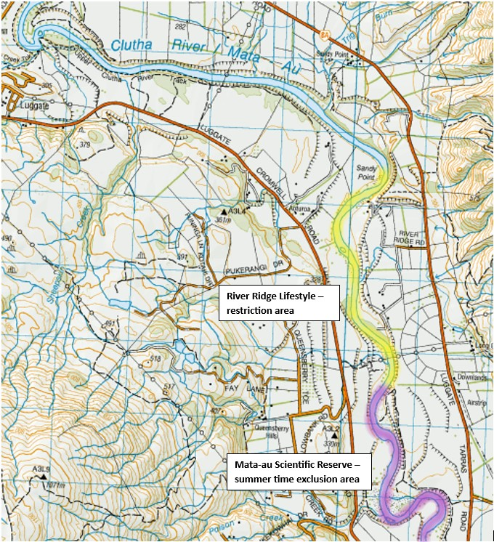

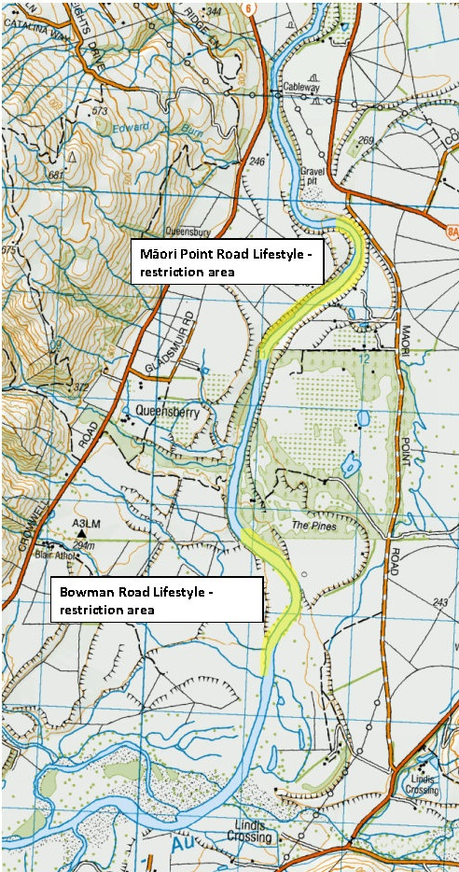

- The area comprising the delta portion of the Clutha River / Mata-Au from the confluence with Lake Dunstan (NZTM 2000: E1307834 N5018386) to the confluence with the Lindis River (NZTM 2000: E1310744 N5024139) is excluded from the operational area. [CODC only]

- The area known as “Devil’s Nook” from 100 m upstream of the confluence of Luggate Creek with the Clutha River / Mata-Au (NZTM 2000: E1305436 N5038955) and for a distance of 350 m downstream, terminating at the downstream extent of the island within Devils Nook (NZTM 2000: E1305651 N5039249 is excluded from the operational area. [QLDC only]

- The total height of the dredge, including any antenna or other fixtures that can articulate and extend vertically above the craft, must be no more than 7.5 metres vertically above the water line.

- The consent holder must maintain a horizontal and vertical 15 metres setback to any high voltage transmission line at all times.

- The consent holder must take all measures to ensure the dredge and associated equipment is secured in high flows and flooding events to prevent any obstruction or blockage in river channel and damage to any bridges, dams or other structures.

Fuel Storage

- Prior to the exercise of this consent, the Consent Holder must ensure that:

a) an industry standard hose and filler nozzle with automatic cut-off is fitted for refuelling equipment;
b) an additional shutoff valve is fitted to the handle and a remote stop push button and cable accessible at the filler nozzle location to stop the pump at the bulk tank;
c) the bulk onshore fuel tank is double skinned or bunded and is located in an area which is setback 50 metres is above 1 in 50 year flood levels, in a safely accessible location;
d) spill kits are located at the bulk tank and onboard the dredge; and
f) all staff receive training in the location and use of spill kits.

- Each time the fuel tank is to be relocated, the consent holder must provide the relevant consent authority a copy of the proposed location for certification that the proposed location complies with the District Plan Standards prior to relocation. Within 5 days of the fuel tank being moved, the ORC and QLDC Harbour masters must be provided with written notice and a plan which shows the location of the fuel tank.

- The fuel hose must be stored at least 5m away from the waters edge when not in use.

Slipway [For CODC ONLY]

- The slipway must be located at NZTM 2000: 1,310,061-5,035,771

- The consent holder must not excavate or disturb any riverbanks or disturbance of vegetated areas adjoining the Clutha River/ Mata-Au, except as required to establish the access at the slipway.
- Prior to commencing excavation the consent holder shall establish the location of any identified archaeological sites within 100m of the slipway and ensure that the slipway construction does not affect those sites.

- Erosion and sedimentation must be managed on the site during the installation of the slipway. Measures must be taken and devices installed, where necessary, to divert clean runoff away from disturbed ground.

- Any areas of earthworks shall be resown in grass immediately following completion of the earthworks.
- The slipway must be maintained in an erosion proof state.
- At the expiry of this consent, the consent holder the slipway must be reinstated to match the adjacent ground conditions and contours.
- The shipping containers located at the slipway must be positioned and coloured to comply with Rule 4.7.6A and 4.7.6D of the Central Otago District Plan.
- All materials associated with the operation of the dredging operation must be stored within the shipping containers and must be not kept loose on the site.
- Following completion of dredging and removal of the vessel from the River all structures and materials associated with the operation shall be removed from the site.

- If the consent holder:
    - discovers koiwi tangata (human skeletal remains), waahi taoka (resources of importance), waahi tapu (places or features of special significance) or other Maori artefact material, the consent holder must without delay:
      - notify the Consent Authority, Tangata whenua and Heritage New Zealand and in the case of skeletal remains, the New Zealand Police.
      - stop work within the immediate vicinity of the discovery to allow a site inspection by Heritage New Zealand and the appropriate runanga and their advisors, who must determine whether the discovery is likely to be extensive, if a thorough site investigation is required, and whether an Archaeological Authority is required.
Site work may recommence following consultation with the Consent Authority, Heritage New Zealand, Tangata whenua, and in the case of skeletal remains, the New Zealand Police, provided that any relevant statutory permissions have been obtained.
    - discovers any feature or archaeological material that predates 1900, or heritage material, or disturbs a previously unidentified archaeological or heritage site, the consent holder must without delay:
      - stop work within the immediate vicinity of the discovery or disturbance; and
      - advise the Consent Authority, Heritage New Zealand, and in the case of Maori features or materials, the Tangata whenua, and if required, must make an application for an Archaeological Authority pursuant to Heritage New Zealand Pouhere Taonga Act 2014; and
      - arrange for a suitably qualified archaeologist to undertake a survey of the site.
Site work may recommence following consultation with the Consent Authority.
Review of consents

- The Consent Authority may, in accordance with Sections 128 and 129 of the Resource Management Act 1991, serve notice on the Consent Holder of its intention to review the conditions of this consent during the period of three months either side of the date of commencement of this consent each year, or within two months of any enforcement action taken by the Consent Authority in relation to the exercise of this consent, for the purpose of:

- Determining whether the conditions of this consent are adequate to deal with any adverse effect on the environment which may arise from the exercise of the consent and which it is appropriate to deal with at a later stage, or which becomes evident after the date of commencement of the consent;
- Ensuring the conditions of this consent are consistent with any National Environmental Standards, relevant regional plans, and/or the Otago Regional Policy Statement;
- Reviewing the frequency of monitoring or reporting required under this consent.

- The Consent Authority may, in accordance with Sections 128 and 129 of the Resource Management Act 1991, serve notice on the Consent Holder of its intention to review the conditions of this consent within 3 months of being provided the report pursuant to condition 9 to incorporate any recommendations from the acoustic expert into these conditions.

Advice notes

- Vessels performing work under other electricity lines must maintain a 4 metres minimum approach distance from the conductors as per New Zealand Electrical Code of Practice for Electrical Safe Distances

- This consent does not confer any right of access over any land. Any arrangements necessary for access are the responsibility of the consent holder.

